Jacob Perry

8/9/2024

Project 3 – Inventory Tracker App Launch Plan

This newly created mobile application will launch on the Google Play Store. At the moment, the only version of this application is written in Java on the Android Studio IDE. If at some point I rewrote the application to be launched on the Apple App Store, we could follow similar steps to this Android launch plan.

The description of this application will be simple, and straight to the point. I will also keep in mind the target userbase when coming up with a description. I am thinking of something like “An application designed to make managing inventory a no brainer. With this inventory tracker application, you can maintain and edit a fully customizable inventory. Never unexpectedly run out of stock again with our user focused notification system. Manage your clothing stock, warehouse inventory, classroom supplies, or anything else you can think of. Your skill level with inventory management is irrelevant with this app. Anyone from an experienced warehouse manager to a first-time small business owner will find navigating our app easy and enjoyable.”

The logo for my app will be something simple, but it will also catch a Google Play Store browser’s eye. Here is a sample application icon to give an idea of what type of image I am thinking of. This image was generated with DALL-E. I chose the colors in this icon image based on the color scheme used in the actual application.

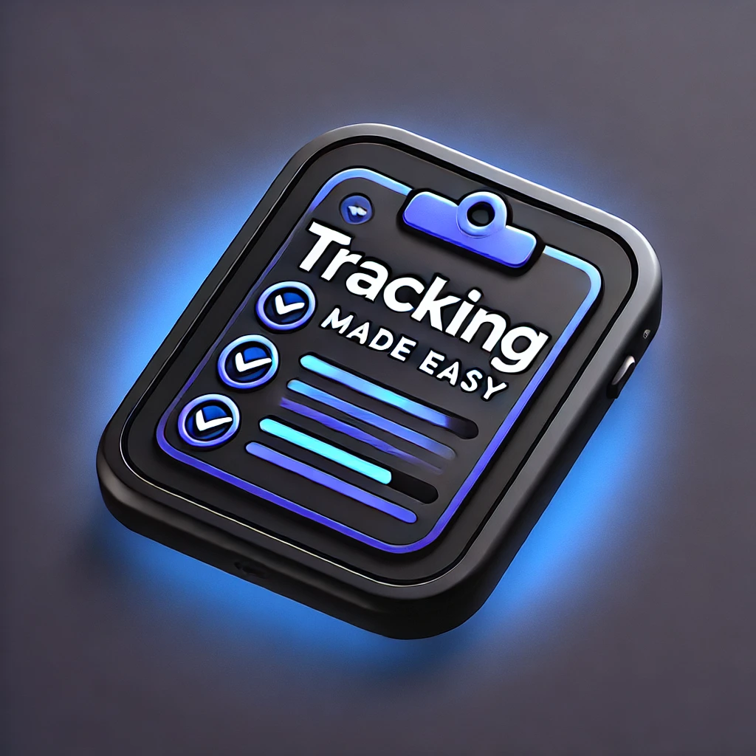

Although this application was coded using API level 31, if I were to actually release it on the app store, I would have used API level 28. This would help accommodate Wear OS users according to the Google release guidelines. Being able to access this inventory app on the go is a big part of its appeal. This would also allow users who may not have the most current smart devices to be able to make use of my app as well. If this app were to be prepared for an actual launch, I would also make it compatible with as many devices as possible. This app was designed solely using an Android emulator of a Pixel 8 Pro running API level 35.

Currently, my app only requests permissions for SEND_SMS, RECEIVE_SMS, and READ_SMS. It also uses the telephony Android feature. If this were to be an application that I was planning to officially launch to the public, I would play around with the idea of requesting camera permissions as well. This would be accommodating to the user so they could use an actual picture of the inventory they are managing. This would add another layer of customization to the application that would better meet the needs of my target audience.

In my experience, for just about every paid app that serves a purpose, there is usually a free version that more than likely has more downloads. Users are often more likely to lean towards a free application rather than paying a fee. Even if the cost of the app is only a few dollars. With the current simplicity of the application, I do not think I could justify putting a dollar amount to it for users to download. I am much more inclined to include non-invasive ads within the app. I would have ads on the very bottom banner of the screens. I would offer an option to go ad-free for a one-time cost of one to two dollars. I have found that within all the different types of apps that I have used, this type of advertising seems to be the least annoying. There are few things more frustrating when using an app than when an ad pops up at an inopportune time and takes up most of the screen. Especially when the ad must run for a designated amount of time before the user is able to close it. My goal for the launch of this app is to reach as much of my target user base as possible. I am also aiming to satisfy all potential users of my app with a stress and annoyance free user experience.